Relics & Rods
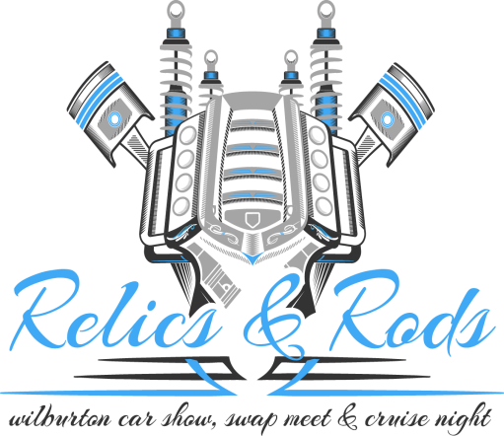
Car Show June 24, 2017
Swap Meet - June 23-25, 2017 at 1108 Highway 2 North
Vendor Spaces Available – 10’ x 20’ - $35 for 3 days
Cruise Night – June 24, 2017 – Downtown Wilburton
Burn Out - June 24, 2017 - 1300 Highway 2 North
Vendor Application:
Name _____________________________________________________________________________________
Address:___________________________________________________________________________________
City:___________________________________________________State:____Zip Code:______________________
Phone:___________________________________________E-mail:______________________________________
Type of Merchandise: ___________________________________________________________________________
Release and Waiver of Liability:
Wilburton Main Street or any other sponsor or promoter of this event does not assume any responsibility for damage, destruction, or loss of exhibitor’s property of any cause. The exhibitors agree to indemnify and hold harmless the above promoters & sponsors or others of the event from any inability and expense for any injury, property damage or any other loss.
Signature:_________________________________________ Date:________________________
Please send check payable to : Wilburton Main Street
P.O. Box 856
Wilburton, OK 74578
Call at 918-465-2254
mainstreetwilburton@yahoo.com
